# M i k r o T i k R o u t e r O S W o r k s h o p Q o S B e s t P r a c t i c e

Chicago,IL MUM USA 2008

# Plan

Discuss best QoS practice for

Large scale user speed limitations Prioritization of traffic based on traffic type

Implement best practice

You will be able to follow the progress – just connect to SSID “QoS” and open up the Winbox to address 10.1.1.254 (default user name and password)

# User Limitation



T3/E3 line

~40 Mbps

●You have more than 400 clients

●**Task:**

●Divide clients into 3 groups

* Business (4Mbps/1Mbps) connection
* Standard (750kbps/250kbps) connection
* Basic (375kbps/125kbps) connection

**© MikroTik 2008** **3**

# Simple Queue For Each Client

Each simple queue creates 3 separate queues:

One in global-in (“direct” part) One in Global-out (“reverse” part) One in Global-total (“total” part)

Simple queues are ordered - similar to firewall rules

further down = longer packet processing further down = smaller chance to get traffic

(necessary to reduce number of queues)

# Possible Solutions

RouterOS have 4 queue types:

FIFO – First In First Out (for Bytes or for Packets) RED – Random Early Detect (or Drop)

SFQ – Stochastic Fairness Queuing

PCQ – Per Connection Queuing (MikroTik Proprietary)

Firewall Mangle and Address-lists Queue Tree

# Default Queue Types

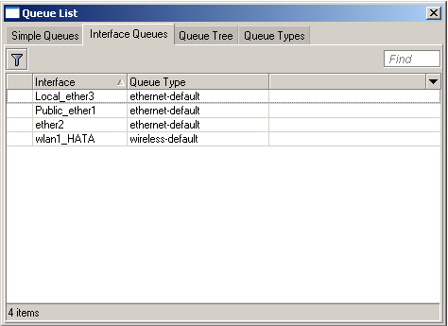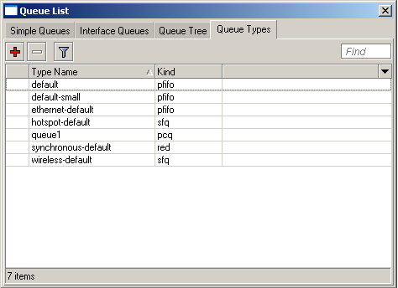

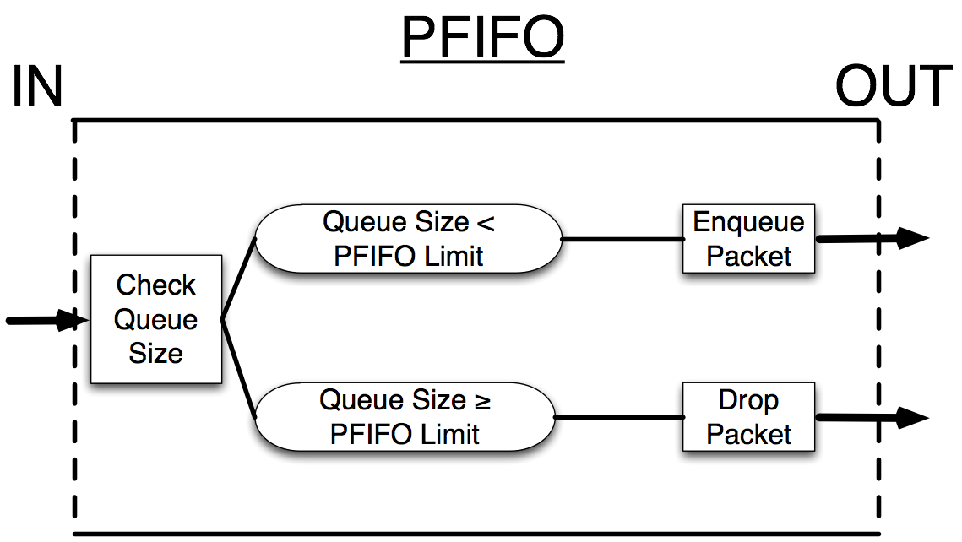

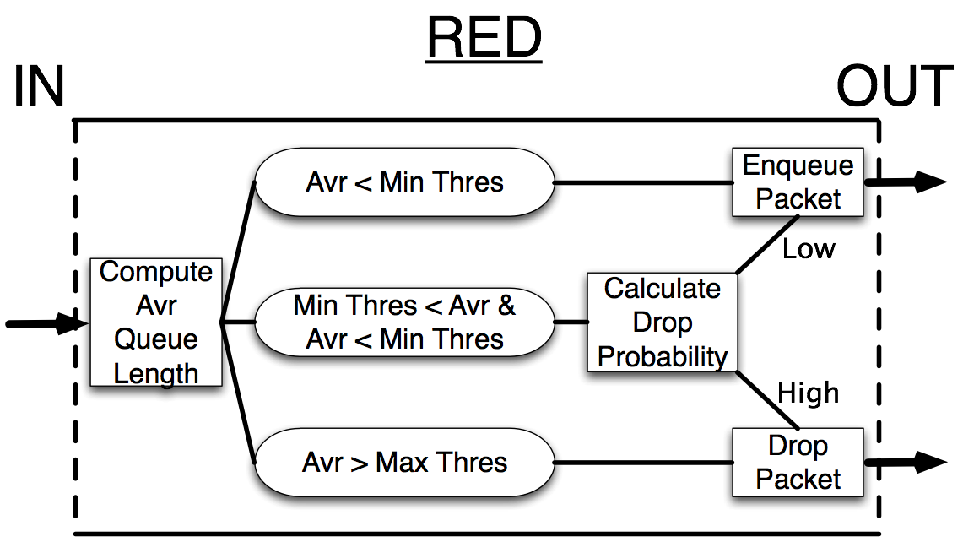

## Behaviour:

SFQ

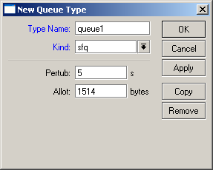Based on hash value from source and destination address SFQ divides traffic into 1024 sub-streams

Then Round Robin algorithm will distribute equal amount of traffic to each sub-stream

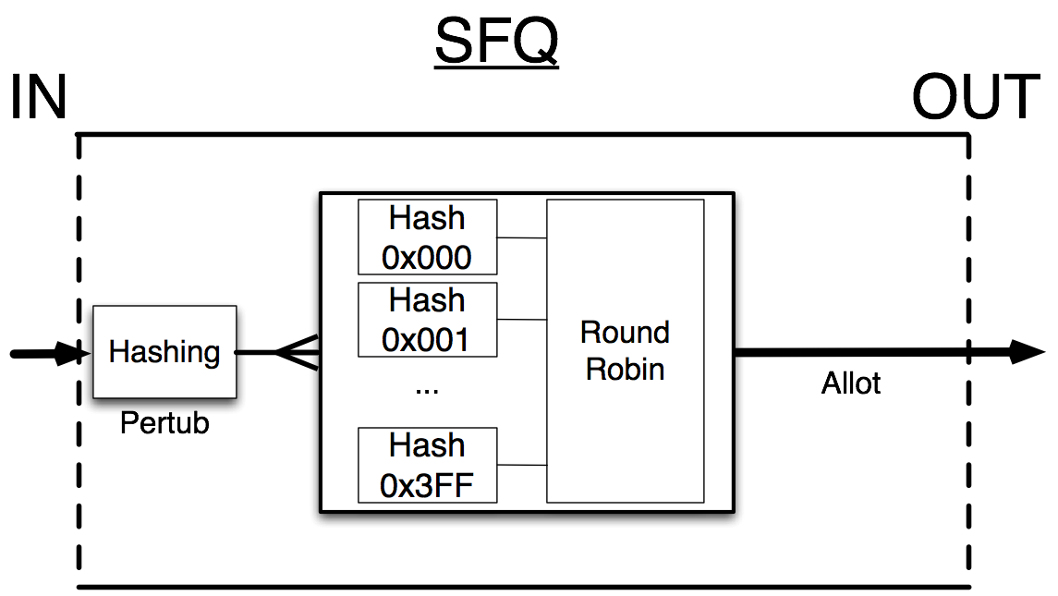

## Behaviour:

PCQ

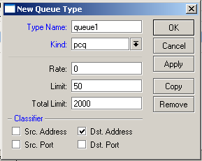Based on classifier PCQ divides traffic into sub- streams. Each sub-stream can be considered as FIFO queue with queue size specified by “limit” option

After this PCQ can be considered as FIFO queue where queue size is specified by “total-limit” option.

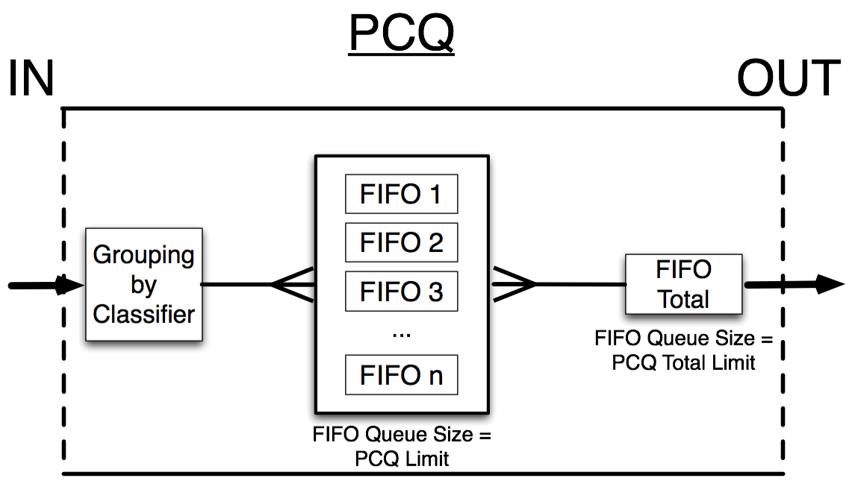

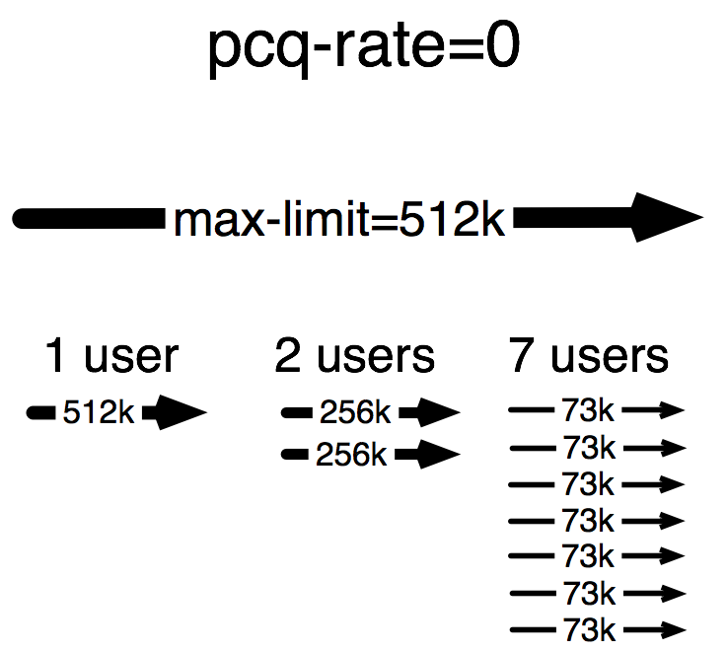

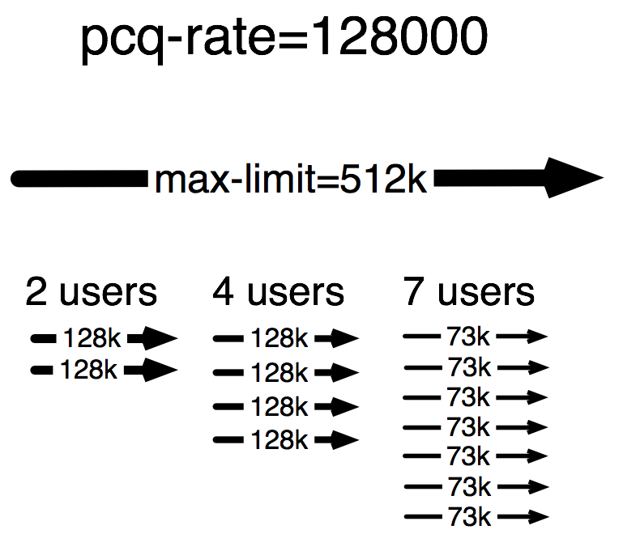

# Plan

Create an address list for client classes Use “connection-mark” (mangle) feature to

classify all connections based on client class

Use “packet-mark” (mangle) feature to classify all traffic based on client class

Create a PCQ queue for each client class with rate option specified

...what about user-user communications???

...what about unmarked traffic ?

# Address Lists

**© MikroTik 2008** **16**

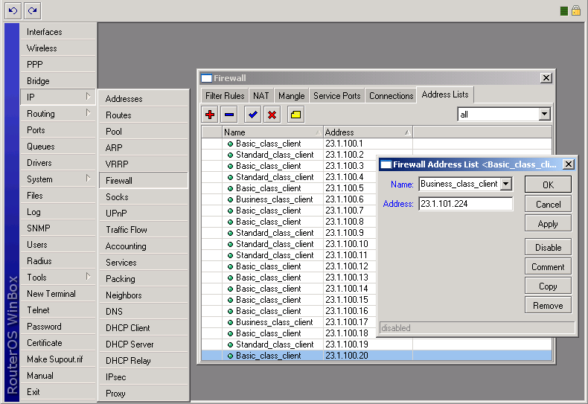

# Where?

There are 5 places to mangle There are 4 places to limit

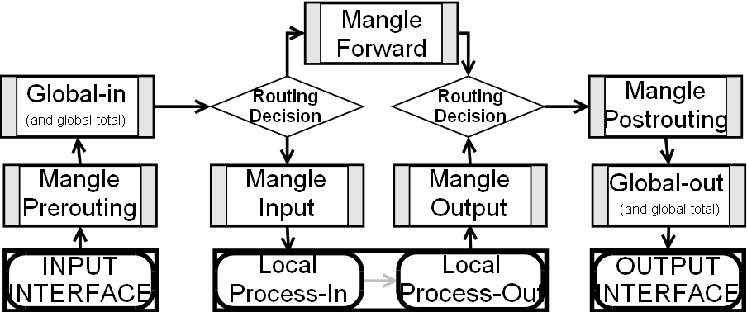

# Connection-mark rule

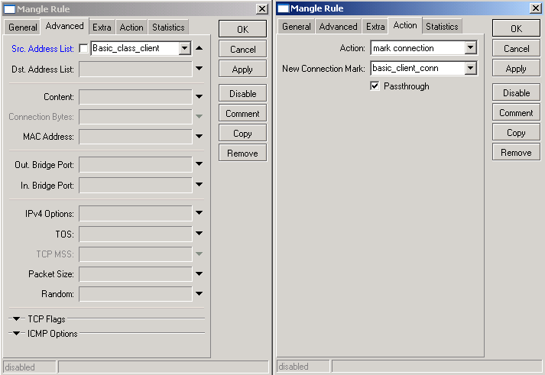

Packet-mark rule

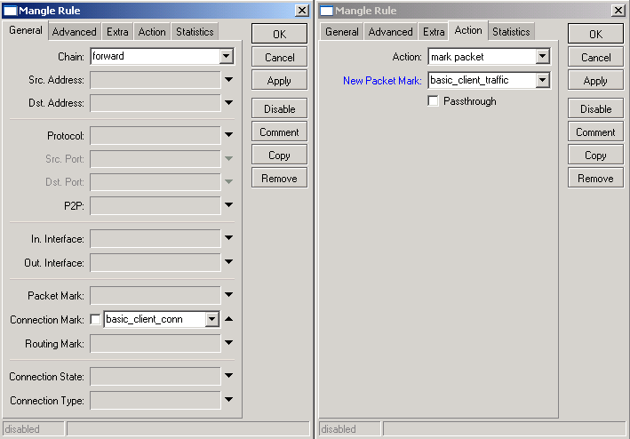

# Working Mangle- Winbox view

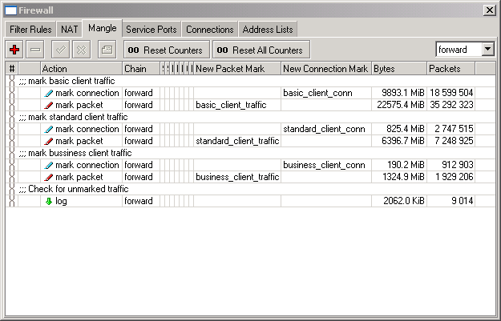

Working Mangle- Export view

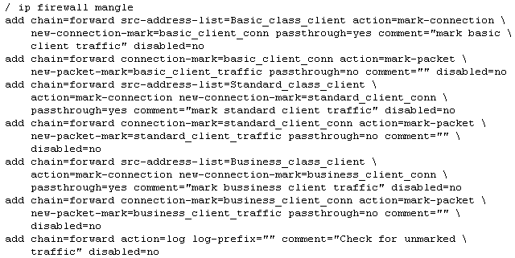

Queuing Placement

Limitation for in mangle chain “forward” marked traffic can be placed in the “global-out” or interface queue

If queues will be placed in the interface queues

queues on the public interface will capture only client upload

queues on the local interface will capture only client's download

If queues will be placed in global-out download and upload will be limited together (separate marks needed)

# PCQ Types – Winbox View

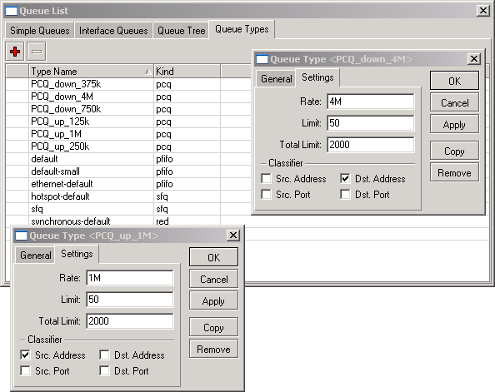

Queue Tree – Winbox View

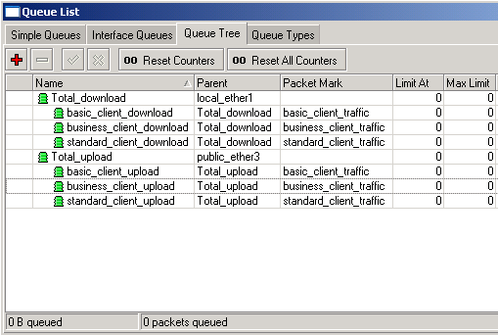

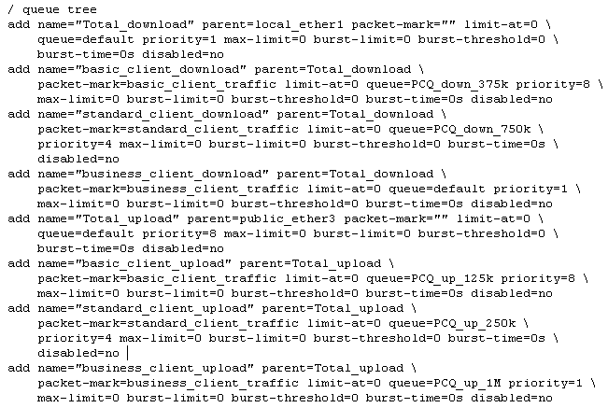Queue Tree – Export View

PCQ Queue Size

It can take only 40 users to fill the queue

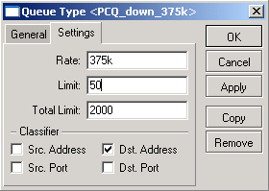

(because total_limit/limit = 2000/50 = 40)

It is necessary to increase “total_limit” or (and) decrease the

Total_limit = X can take up to

X*(2000 bytes + 200 bytes) of RAM

2000 bytes – buffer for 1 packet

200 bytes – service data for 1 packet

total_limit = 2000 =< 4,2MB RAM total_limit = 5000 =< 10,5MB RAM

“limit” value

There must be at least 10-20 packet places in queue available per user

# PCQ Adjustments

There are ~340 Basic class clients so:

pcq_limit = 40

pcq_total_limit = 7000 ( ~20*340) (~15MB)

There are ~40 Standard class clients so:

pcq_limit = 30

pcq_total_limit = 1000 ( ~20*40) (~2MB)

There are ~20 Business class clients so:

pcq_limit = 20 (!!!)

pcq_total_limit = 500 ( ~20*20) (~1MB)

# Traffic Prioritization

T3/E3 line

~40 Mbps

~5Mbps abroad

Business Class Clients

You have problems with on-line

communications (video, audio, VOIP, games)

**Task:**

Make necessary traffic prioritization

Basic Class Clients



Standard Class Clients

**© MikroTik 2008** **28**

# Prioritization plan

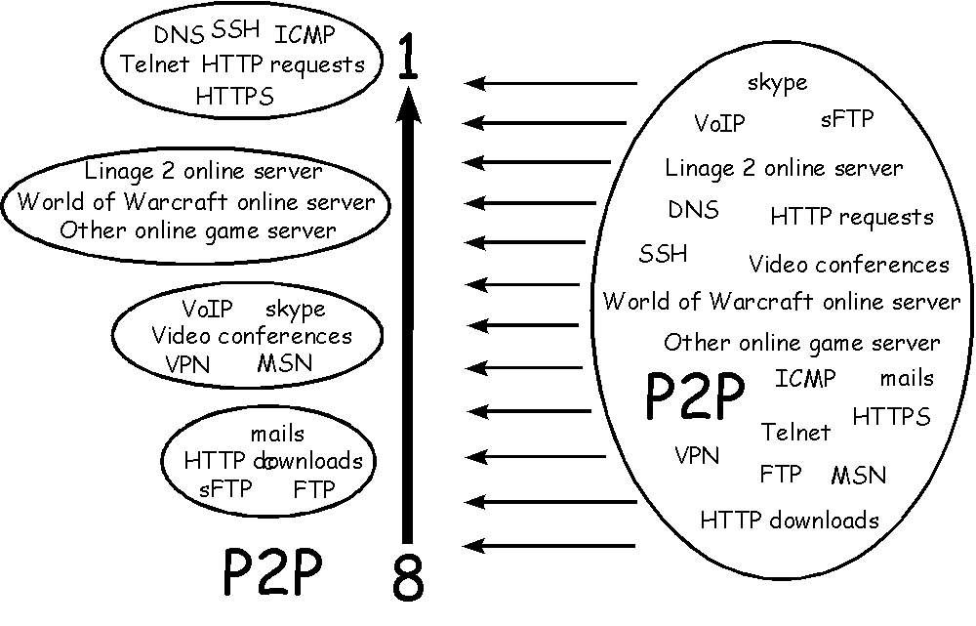

# Where?

There are 5 places to mangle There are 4 places to limit



# How?

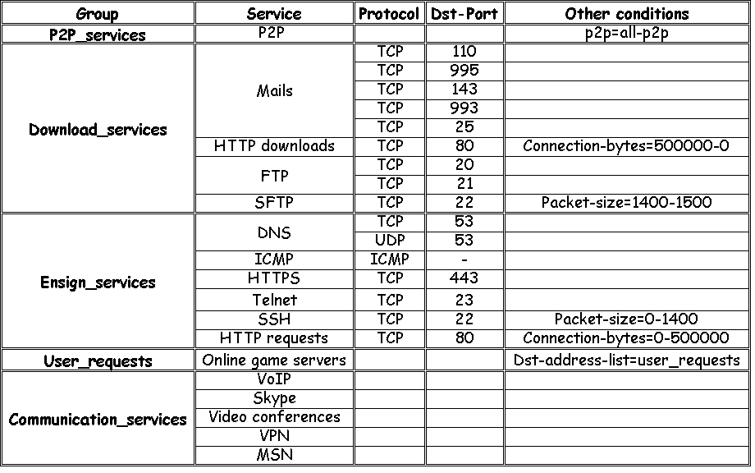

Priorities

Create packet marks in the mangle chain “Prerouting” for traffic prioritization in the global- in queue

Ensign_services (Priority=1) User_requests (Priority=3) Communication_services (Priority=5) Download_services (Priority=7) P2P_services (Priority=8)